Towards haptic learning on a smartwatch

【Summary】：

We use Sony Smartwatch 3 to teach users Morse code when participants are concerned about unrelated tasks.

【Contribute】：

• Provide evidence that smartwatch haptics can convey a new skill and possibly enable passive learning.

• Examine performance differences between two different doses of passive stimulation.

【Apparatus】：

In this experiment, smart watches and headphones were used to deliver passive stimuli. The watch stimulates a repeating sequence of Morse codes on the user's wrist. The dots and dashes are 100 ms and 300 ms vibration taps, respectively. Each set of dots and dash stimuli representing a letter begins with an audio cue naming the letter. There is a 500 millisecond pause between the stimuli representing each lot. We chose an Android watch for simple open source programming. This study considered four of the most common smartwatches, including Moto360, LG G, Sony SmartWatch 3, and Samsung Gear. The Sony SmartWatch 3 was selected as the product with the best affordability, battery life, and general usage among smartwatch users.

【Procedure】：

The user's Morse code reproduction was tested using a smartphone application. They are asked to enter a combination of "." And "-" that represents each letter in the word they are learning. No feedback accuracy. In a distraction task, the user puts on a watch and noise-canceling headphones and announces each letter. The vibrations produced by a watch are the only source of information about Morse code. We compared two conditions in this study to determine how much time the system requires passive stimulation. For each word, all users will receive passive tactile stimuli during the first 8 minutes of distracting tasks, and in the next 8 minutes (the "16-minute condition"), half of the users will continue to stimulate. The study ends with a backtest of all letters.

【Results】：

We calculated accuracy as the percent of totally correct re-sponses. All users showed significant improvement from pre- to post-test knowledge of Morse code (paired t-test t(5)=11.62, p<0.001). See Figure 1-left.

Several users agreed to return for recall tests in the days fol-lowing the study. They were asked not to review any Morse code in between tests. The recall test was identical to the pre/post-tests of all letters. These recall tests were adminis-tered 1 day (24 hours) and 3 days after the end of the study session. Results on the recall test were approximately consis-tent with the user’s result on the post-test (“study end” Figure 1-right); no significant difference was found.

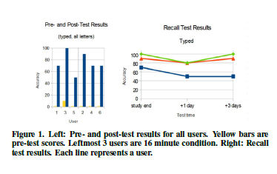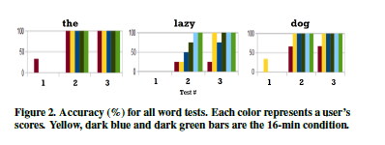

【Important Reference】:

C. Seim, S. Reynolds-Haertle, S. Srinivas, and T. Starner. Tactile taps teach rhythmic text entry: passive haptic learning of morse code. In Proceedings of the International Symposium on Wearable Computers, pages 164–171. ACM, 2016.